Project Design Phase-II

Technology Stack (Architecture & Stack)

Parameter | Value
Date | June 18, 2026
Team ID | Solo Developer (Vishal Gudla)
Project Name | ShopEZ — A MERN Stack E-commerce Application
Maximum Marks | 4 Marks

Technical Architecture Overview
The ShopEZ architecture is structured around a decoupled three-tier system. The customer or administrator interacts via a single-page application (SPA), which routes stateless requests through a custom API wrapper to a specialized backend REST API server. The server executes underlying business operations in a transaction-safe manner before mapping data payloads directly into a persistent document data store.
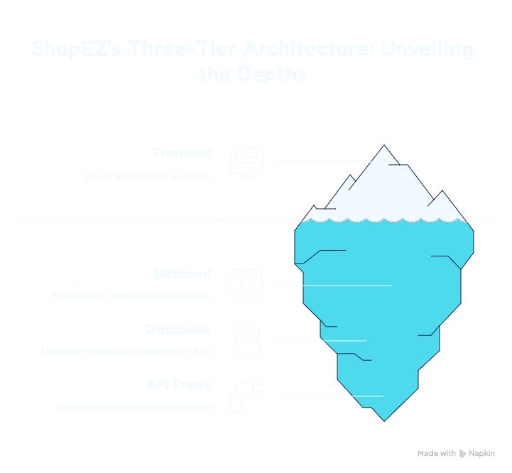

Table-1: Components & Technologies

S.No | Component | Description | Technology
1 | User Interface | Single Page Application (SPA) providing a responsive shopping storefront and a dedicated administrative metric control board. | React 18, TypeScript, Vite, TailwindCSS, Lucide React, React Router DOM v7.
2 | Application Logic-1 | Client-side state tracking management and unified global service wrapper configuration. | React Context API (AuthContext.tsx, CartContext.tsx), Service Wrapper (lib/api.ts).
3 | Application Logic-2 | Backend REST API orchestration serving server-side entry pipelines and routing incoming client payloads. | Node.js, Express.js framework.
4 | Application Logic-3 | Model-View-Controller (MVC) logic managing authentication, cart mutations, order execution, and dashboard metrics. | Express Controllers (authController, productController, cartController, orderController, adminController).
5 | Database | Persistent object-relational mapping defining data schemas for user accounts, products, configurations, and transactional states. | MongoDB using Mongoose ODM schemas.
6 | Cloud Database | Cloud-hosted instance or locally decoupled database store used to persist application parameters across distinct sessions. | MongoDB Atlas / Local MongoDB Compass instance.
7 | File Storage | Current local static reference point with explicit scaling scope configured for remote Content Delivery Networks (CDNs). | Local Filesystem URLs (Current) / Cloudinary or Amazon S3 integration (Planned enhancement).
8 | External API-1 | Third-party secure transaction pipeline integration planned to support localized Indian payment systems. | Razorpay API / Stripe API integration (Planned enhancement).
9 | External API-2 | Third-party notification messaging automated pipeline scheduled to dispatch real-time fulfillment status changes to user lines. | SendGrid API / Twilio SMS API webhook hooks (Planned enhancement).
10 | Infrastructure (Server / Cloud) | Decoupled local system environment running autonomous frontend and backend engines via terminal isolation. | Local Host Execution (Backend on http://localhost:8000 via nodemon; Frontend on http://localhost:5173 via Vite proxy).

Table-2: Application Characteristics

S.No DOCX | Characteristics DOCX | Description DOCX | Technology used DOCX
1 | Open-Source Frameworks | Utilization of highly active web libraries and runtime runtimes to execute component mapping, API parsing, and model schemas. | React 18, Node.js (v18+), Express.js, Mongoose ODM, TailwindCSS.
2 | Security Implementations | Enforcement of irreversible string hashing for credentials, stateless communication validation, and explicit role access gates. | JSON Web Tokens (JWT) Bearer tokens, bcryptjs password hashing, security middleware guards (protect, adminOnly).
3 | Scalable Architecture | Structural design relying on clear separation of concerns, ensuring independent data manipulation rules and easy subsystem expansion. | 3-Tier Model-View-Controller (MVC) architectural pattern decoupling models, logic routes, and custom interface wrappers.
4 | Availability | Independent structural execution of runtime parameters, allowing isolated frontend modifications without interrupting live backend engines. | Dual-terminal host segmentation with a localized Vite internal reverse-proxy layer to bypass cross-origin browser restrictions.
5 | Performance | Optimization configurations preventing pipeline blocks during high traffic, providing rapid hot reloads and asset deliveries. | Vite development bundles, JWT-driven stateless server loads, and isolated single-sequence MongoDB transaction operations.

